**SAMPLE MULTIPLE CHOICE**

1. Glucose is not normally found in the urine because it
2. does not pass through the walls of the glomerulus
3. is retained in the blood by osmotic pressure
4. is reabsorbed by the proximal convoluted tubule
5. is removed by the cells of the body before the blood reaches the kidney
6. Which of the following statements about the fluid mosaic model for membrane structure are correct?
7. Some proteins cross the lipid bilayer and allow certain molecules to enter and exit the cell
8. All of the proteins are held in fixed positions
9. The inner layer of the membrane is hydrophobic (i.e. it repels water)
10. Cholesterol molecules keep the membrane fluid
11. Some proteins on the outer layer of the membrane identify the cell as belonging to the body
12. (i), (iii) & (iv) only
13. (ii) & (v) only
14. (i), (iii), (iv) & (v) only
15. All are correct
16. Athletes who compete in power events ⎯ such as javelin, discus and 100 metre sprints ⎯ have a high proportion of white muscle cells in their skeletal muscles. Which of the following would be true of a white muscle cell?

1. The cytoplasm would have a high concentration of enzymes involved in anaerobic respiration.
2. The number of mitochondria in the cell would be higher than in other types of muscle cells.
3. The production of enzymes responsible for aerobic respiration would be very high.
4. The cell nucleus would be larger than in other muscle cells because fewer enzymes are synthesised.

*Note: The next question refers to the table below.*

|  |  |  |
| --- | --- | --- |
| Relative Concentrations in the Nephron Compared to Plasma. | | |
| Glucose | Hydrogen ions | Urea |
| none | high | high |

1. Where in the nephron would the filtrate values in the table above be found?
2. Distal convoluted tubule
3. Proximal convoluted tubule
4. Afferent Arteriole
5. Bowman’s Capsule
6. The pulmonary artery is unusual because it is:
7. The only blood vessel in the pulmonary circulation
8. An artery carrying deoxygenated blood
9. The longest artery in the body
10. Similar in structure to a vein
11. Which component of the blood plays an important role in blood clotting?
12. Leucocytes
13. Erythrocytes
14. Platelets
15. Red blood cells

The next two questions refer to the following information.

*While examining drops of fluid containing bacteria which form butanoic acid, Louis Pasteur noticed that when the moving organisms came near the edge of a drop they stopped moving.*

1. The process in which Pasteur was involved is best described as
2. forming a hypothesis
3. observation
4. questioning results
5. forming a conclusion
6. Pasteur suggested that the oxygen in the air, near the edge of the drop, might have stopped the bacteria moving. The process involved in making the suggestion is best described as
7. making a generalisation
8. reaching a conclusion
9. developing a theory
10. forming a hypothesis
11. Digestive enzymes are secreted by the
12. pancreas
13. liver
14. gall bladder
15. large Intestine
16. Which of the following statements is correct?
17. Alveoli contract and relax to pump air into the lungs
18. The net movement of carbon dioxide is from inside the alveoli into the capillaries
19. Oxygen diffuses from inside the alveoli into the capillaries
20. The pulmonary artery brings oxygen into the alveoli

The next two questions refer to the information presented below

As part of a research project aiming to treat patients with liver damage, a scientist grew and monitored liver cells in a petri dish. This required the measurement of fluid concentrations in and around the liver cells. The results from one such measurement are shown below.

**Concentration (micrograms/Litre)**

|  |  |  |
| --- | --- | --- |
| **Solute** | **Intracellular Fluid** | **Extracellular Fluid** |
| Glucose | 30 | 50 |
| Sodium | 25 | 35 |
| Chloride | 15 | 20 |
| Potassium | 5 | 25 |
| Bicarbonate | 20 | 20 |

1. Based on this table of results, which of the following statements is correct?
2. these cells must use energy to obtain glucose and are in danger of swelling
3. these cells will lose sodium, chloride and bicarbonate by diffusion
4. these cells will lose water to the extracellular fluid
5. the scientist must add more bicarbonate to the surrounding fluid
6. The scientist did not add urea to the solution surrounding the liver cells, however small traces of urea were soon detected in the petri dishes. This is because…
7. deamination of proteins occurs in liver cells
8. urea is removed from the cells to maintain osmotic balance
9. liver cells perform aerobic respiration
10. urea is a toxic waste product of respiration
11. Which one of the following occurs in the digestive system?
12. Food moves through the oesophagus by diffusion
13. Digestion of starch occurs in the stomach
14. Absorption of digested material occurs in the small intestine
15. Digestion of fats occurs in the large intestine
16. The large intestine
17. secretes bile
18. absorbs vitamins
19. produces glucose
20. releases sodium bicarbonate
21. Which of the following correctly compares a characteristic of mitosis and meiosis?

|  |  |  |
| --- | --- | --- |
|  | **MITOSIS** | **MEIOSIS** |
| (a) | Different daughter cells are produced. | Daughter cells are identical. |
| (b) | Two diploid daughter cells are produced. | Four haploid daughter cells produced. |
| (c) | Crossing over occurs between chromosomes. | Crossing over does not occur. |
| (d) | Two cell divisions are involved. | One cell division is involved. |

1. Which enzyme functions optimally in a low pH?
2. Intestinal lipase
3. Gastric protease
4. Pancreatic protease
5. Salivary amylase
6. Cilia in the trachea ‘sweeps’ debris towards the
7. alveoli
8. bronchi
9. pharynx
10. bronchioles
11. A 65-year-old man suffers a near fatal heart attack that damages the papillary muscle in his left ventricle. The heart attack is most likely to cause which heart valve to become non-functional?
12. Tricuspid or the right atrioventricular valve.
13. Pulmonary valve.
14. Mitral or bicuspid or left atrioventricular valve.
15. Aortic valve.

*Use the following diagram to answer the question below*.

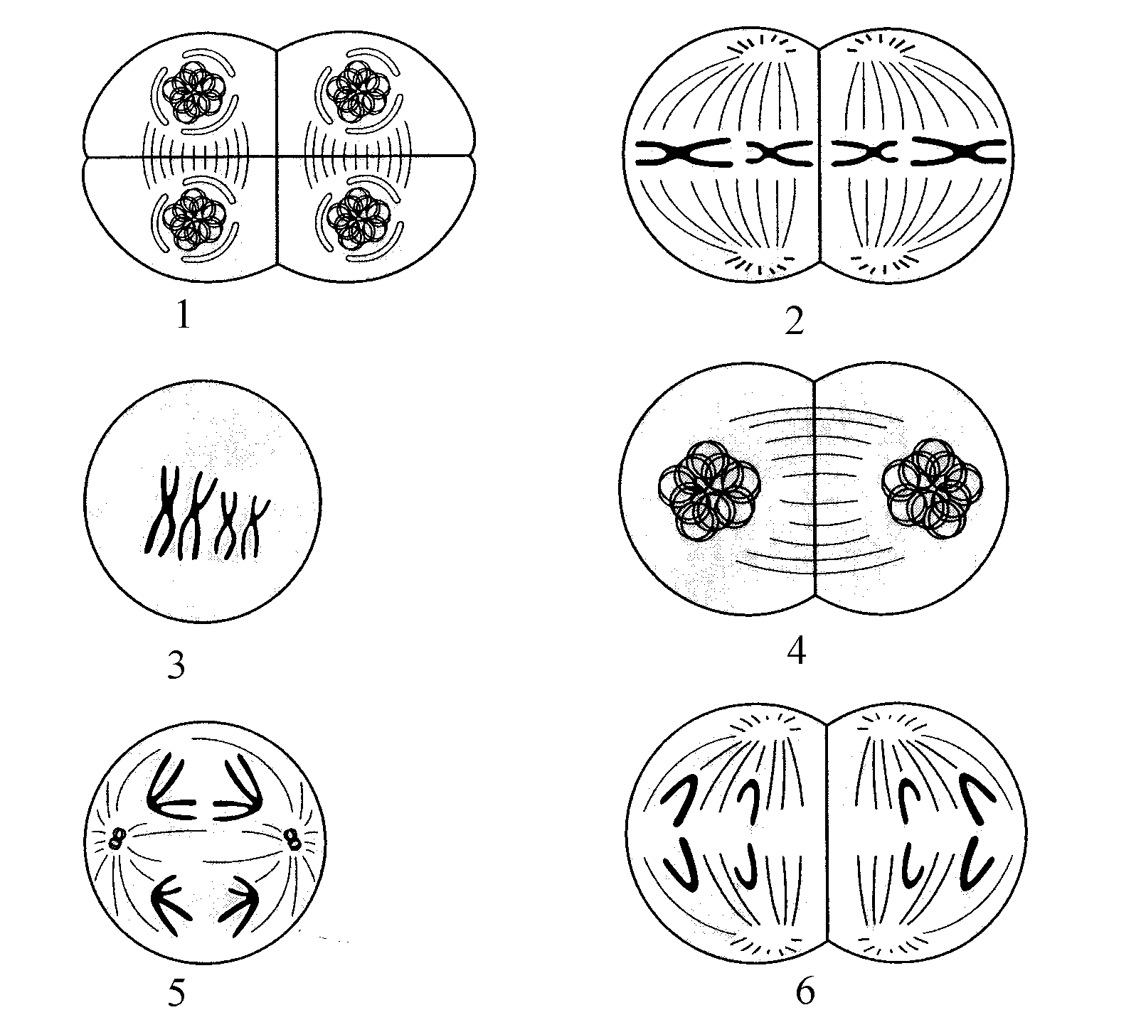

1. The correct order for the stages during meiosis are:
2. 2 6 4 3 5 1
3. 1 3 4 2 6 5
4. 1 2 4 3 5 6
5. 3 5 4 2 6 1
6. Which of the following correctly links tooth type with function and gives the correct number (of that type) for a full adult mouth?
7. Incisors – cutting - 12
8. Canines – tearing – 4
9. Incisors – cutting - 4
10. Premolars – grinding – 12
11. A waste product of anaerobic muscle contraction is:
12. Glycogen
13. Carbon dioxide and water
14. Lactic acid
15. Carbonic acid
16. The basic unit of a protein is called
17. A monosaccharide
18. An amino acid
19. A nucleotide
20. A triglyceride

*Use the following diagram to answer the question below*.

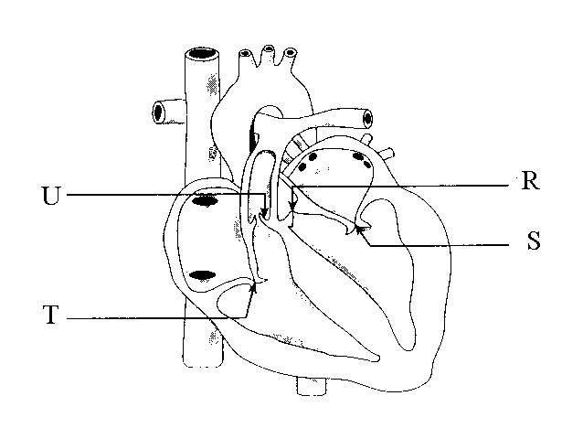

1. Which of the labelled structures prevents blood from re-entering the right atrium from the right ventricle?
2. S
3. R
4. U
5. T
6. During the ventricular systole of the heart
7. the tricuspid or the right atrioventricular valve is closed
8. the aortic valve is closed
9. the ventricular blood volume is increasing
10. blood is entering the left and right atria
11. During the process of mitosis there are a number of clearly visible stages. During which stage do the chromosomes line up on the equator of the spindle?
12. Interphase
13. Prophase
14. Metaphase
15. Anaphase
16. Which of the following is the site of protein synthesis in the cell?
17. Nucleus
18. Cytoplasm
19. Mitochondria
20. Ribosomes

*Use the diagram below to answer the following question*.

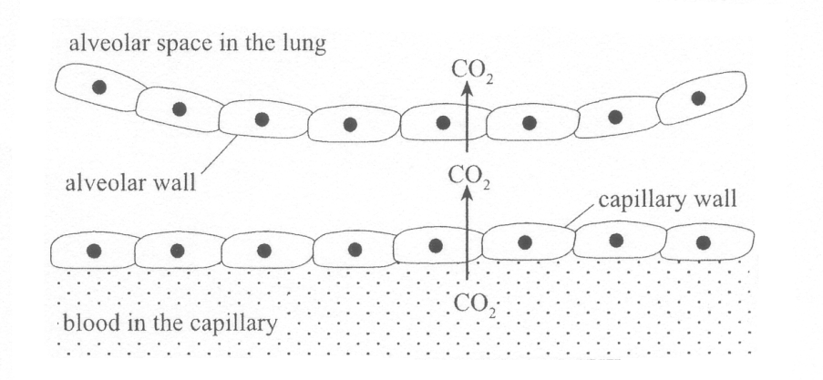

1. Which one of the following statements about the removal of carbon dioxide from the blood is correct?
2. Carbon dioxide is moved from the blood in the capillary into the alveolar space in the lung by active transport.
3. The alveolar wall and the capillary wall are each one cell thick in order to slow the movement of carbon dioxide into the alveolar space in the lung.
4. The constant movement of the blood ensures that the concentration of carbon dioxide in the blood remains higher than that in the alveolar space in the lung.
5. The alveolar wall is spherical in order to decrease the surface area of the lung available for the removal of carbon dioxide.
6. The cylindrical structures which form the spindle fibres during mitosis are called?
7. Endoplasmic reticulum
8. Centrioles
9. Golgi bodies
10. Mitochondria
11. The diagram to the right illustrates the process of:

H20

H20

H20

1. Pinocytosis
2. Osmosis
3. Active transport
4. Diffusion
5. Cells use as their main source of energy which of the following?
6. Sugar
7. Glucose
8. Amino acids
9. Fats
10. All exchanges of fluid, nutrients and wastes between the blood and the tissues occurs across the walls of:
11. The heart
12. Lymph vessels
13. Veins
14. Capillaries
15. Red blood cells are produced by:
16. Yellow bone marrow
17. Red bone marrow
18. Thymus gland
19. Blood
20. In which of the following blood vessels would you expect blood pressure to be the highest?
21. Vena cava
22. Pulmonary artery
23. Aorta
24. Pulmonary vein
25. During ventilation air moves into the lungs. This happens when:
26. There is a downward movement of the diaphragm and an upward movement of the ribs.
27. The intercostal muscles and the diaphragm relax.
28. The internal volume of the thoracic cavity decreases.
29. The internal pressure of the thoracic cavity increases.
30. The flap of tissue that covers the trachea during swallowing is called the:
31. Glottis.
32. Epiglottis.
33. Peristalsis.
34. Larynx.
35. The volume of air that moves into and out of the lungs with each breath is called the:
36. Residual volume.
37. Expiratory volume.
38. Vital capacity.
39. Tidal volume.
40. Which of the following are ways in which carbon dioxide is carried in the blood?
41. Dissolved in the plasma
42. Bicarbonate ions
43. Oxyhaemoglobin
44. Carbamino haemoglobin
45. Carbonic acid
46. (i), (ii), (iv) & (v) only
47. (i), (iii) & (v) only
48. (i), (ii) & (iv) only
49. All
50. Which of the following can be determined as risk factors for heart attacks?
51. Low blood pressure
52. High blood pressure
53. Starvation
54. Lack of exercise
55. Smoking
56. Obesity
57. High fat diet
58. 1, 3, 5, & 7
59. 2, 4, 6, & 7
60. 2, 4, 5, 6 & 7
61. 1, 2, 5, 6, & 7
62. Which part of the digestive system would secrete a fluid with the highest pH?
63. Mouth
64. Stomach
65. Pancreas
66. Small Intestine

**QUESTION 1**

1. Write the name and function of each of the labelled organelles in the table below.

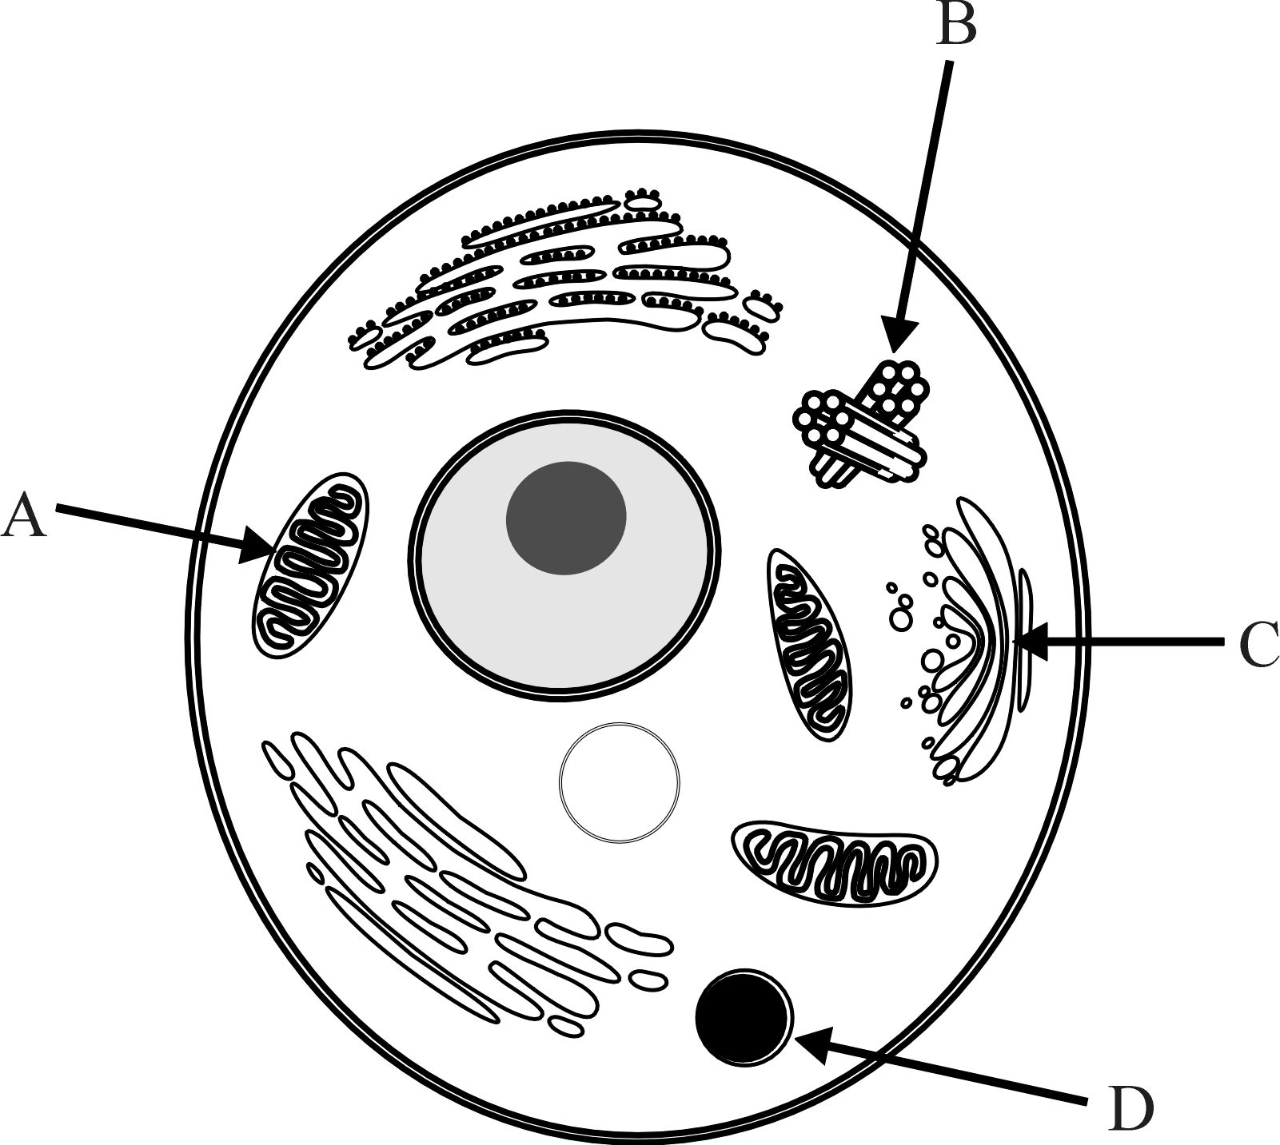

|  |  |  |
| --- | --- | --- |
|  | Name of Organelle | Function of Organelle |
| A |  |  |
| B |  |  |
| C |  |  |

(6 marks)

1. When energy is needed, show how ATP breaks down to release the energy required.

(1 mark)

1. Explain what is meant by ‘the synthesis of proteins’.

(1 mark)

1. Where does protein synthesis occur in the cell?

(1 mark)

**QUESTION 2**

The following diagram shows the major organs of the respiratory system.

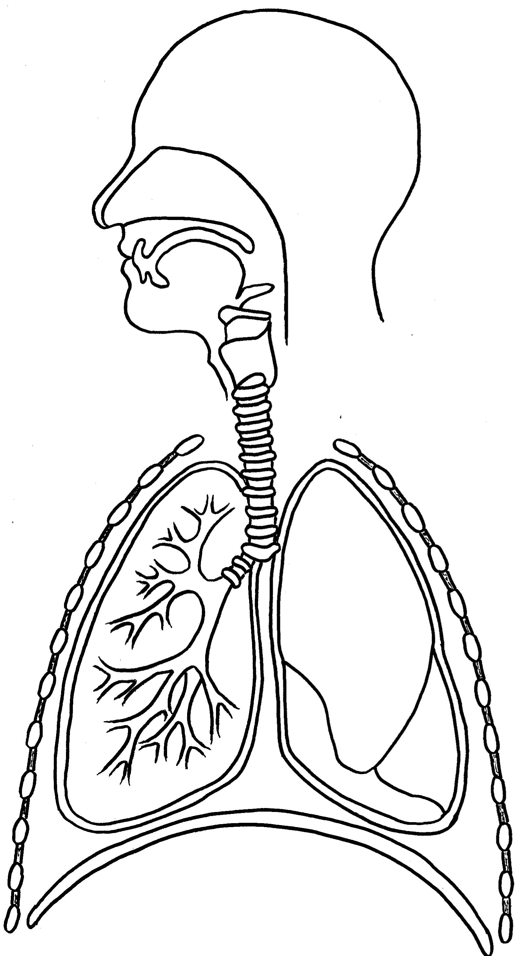

A

B

C

D

E

(a) Label the diagram above using the spaces provided.

(5 marks)

(b) Describe the function of structures A and D

(2 marks)

QUESTION 3

Write a clear description of each of the following. (1 mark each)

1. Hypertension
2. Anaemia
3. Erythrocytes
4. Plasma
5. Vein
6. Oxyhaemoglobin
7. Cardiac Output

**QUESTION 4**

The diagram below shows a partially dissected heart.

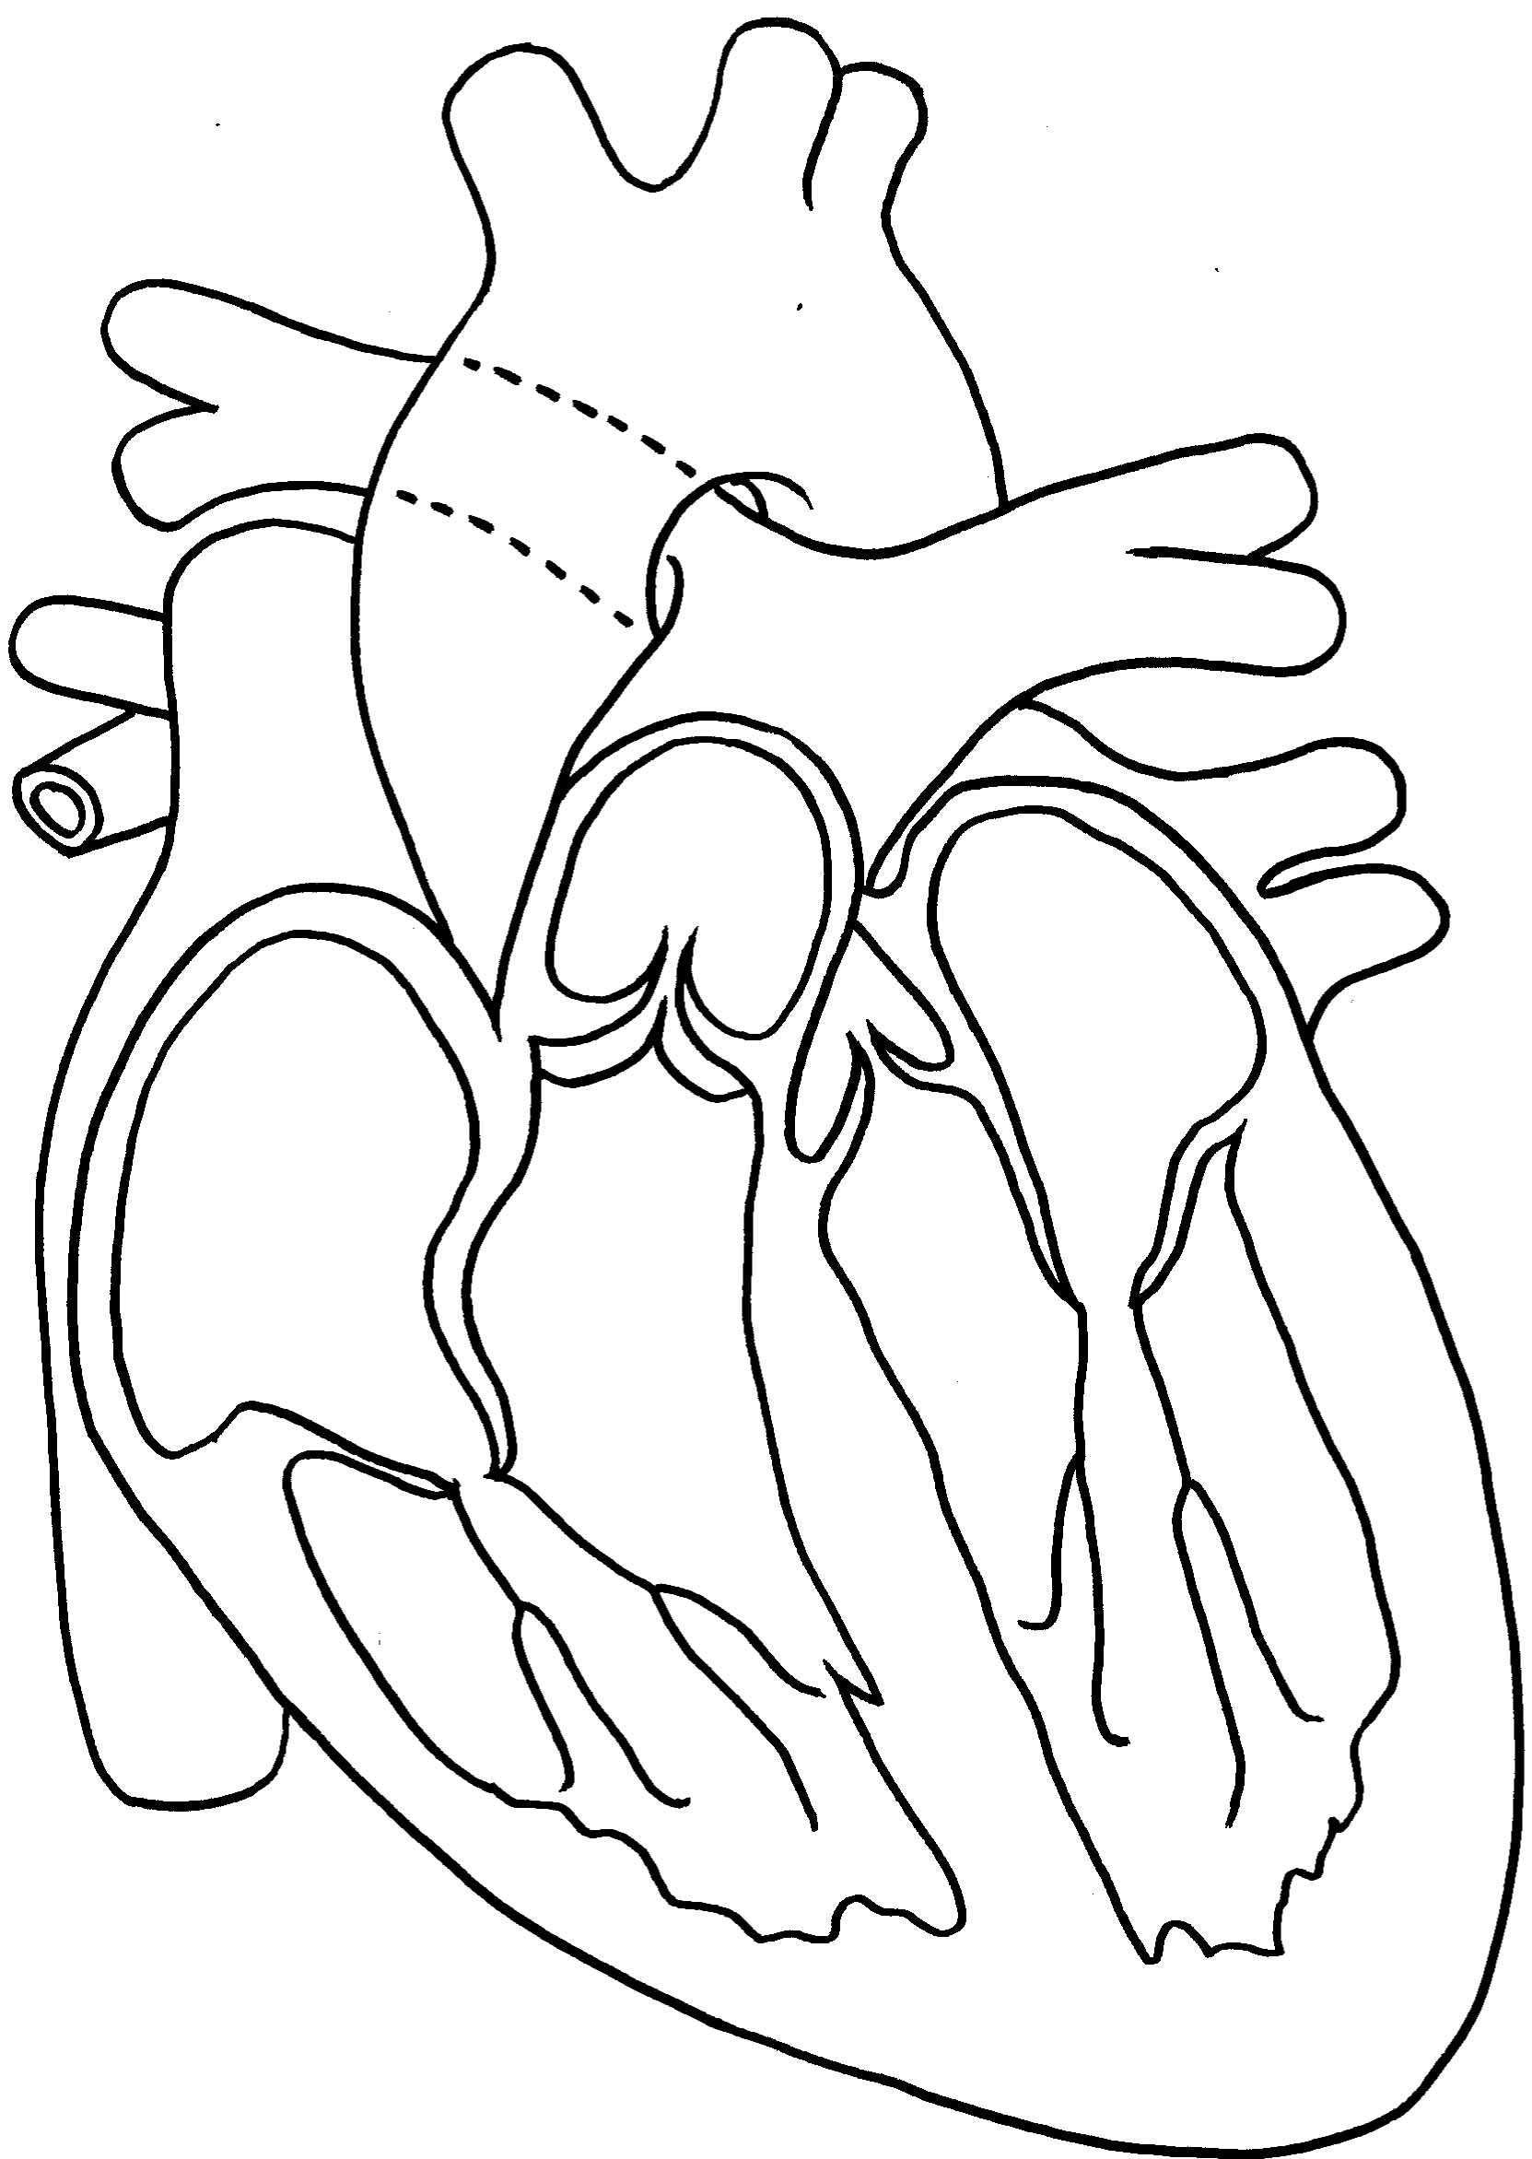

1. Label the diagram above using the spaces provided.

(6 marks)

1. Draw arrows on the diagram to show the direction of blood flow through the heart and major blood vessels.

(1 mark)

1. What is the function of the semilunar valves

(1 mark)

1. During the cardiac cycle the heart makes two distinct sounds which are about 0.3 seconds apart. What are these sounds?

(1 mark)

**QUESTION 5**

In a recent study to examine effective methods of controlling body weight, it was found that a diet high in calcium appears to encourage the body to burn more fat. An experiment was set up using 34 obese, but otherwise healthy adults as subjects. Half of the group consumed 1100mg of calcium per day, whilst the other half consumed 500mg of calcium per day. All individuals followed a diet providing 500 kilojoules less than they usually ate.

After twelve weeks, those on the high calcium diet containing 1100mg of calcium lost, on average, 22 per cent more weight and 60 per cent more body fat than the individuals on only 500mg of calcium.

1. What was the independent variable in the above experiment?

(1)

1. What was the dependent variable in the experiment?

(1)

1. Give two variables, from the paragraphs above, that were controlled in this experiment?

(2)

1. Suggest another variable (not mentioned in the paragraphs) that would need to be controlled.

(2)

1. Suggest two ways to improve the experiment and help validate the result?

(2)

**QUESTION 6**

The diagram below refers to the following three questions (a-c).

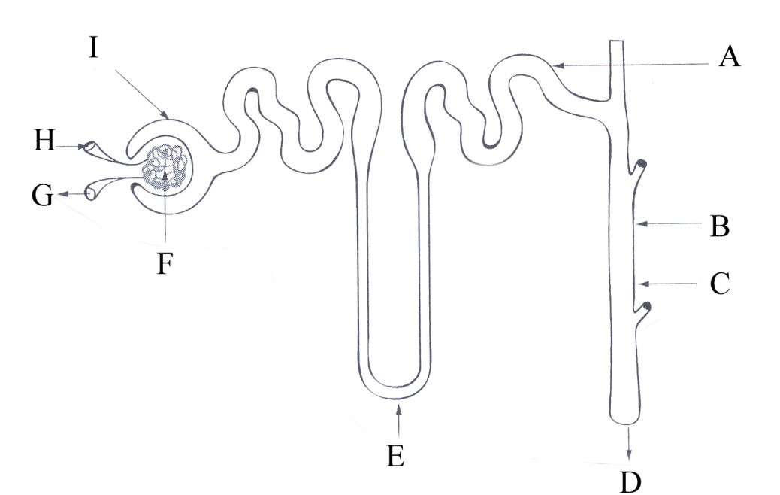

1. Identify the labelled structures

**A** ___________________________________

**E** ___________________________________

**F** ___________________________________ (3)

1. Describe how the composition of the fluid in Part I would be different from the fluid at Part D. (Assume that the person is healthy.)

(3)

(c) Explain why urine is generally more dilute on a cold day.

(2)

**QUESTION 7**

The table below represents the concentration of a variety of substances in fluid samples from different regions of the nephron.

Regions of the Nephron

### Concentration of Solutes (micrograms / Litre)

|  |  |  |  |  |  |
| --- | --- | --- | --- | --- | --- |
| Solute | **Glomerulus** | **Glomerular Capsule** | **Proximal Convoluted Tubule** | **Distal Convoluted Tubule** | **Collecting Duct** |
| **Protein** | 5,000 | 5 | 5 | 0 | 0 |
| **Glucose** | 230 | 230 | 23 | 15 | 25 |
| **Urea** | 55 | 55 | 50 | 60 | 100 |
| **Sodium Ion** | 440 | 440 | 60 | 50 | 75 |

1. Describe the change in protein concentration that occurs between the glomerulus and the proximal convoluted tubule. Explain why this change occurs.

(2 marks)

1. Describe the change in sodium ion concentration that exists between the glomerular capsule and the collecting duct. Provide two explanations for why this change occurs.

(3 marks)

1. Suggest a disease that this individual is suffering from and support your answer with data from the table.

(2 marks)

**SAMPLE EXTENDED ANSWERS**

**Question 1**

1. Identify three diseases that are associated with the middle-aged population of Australia. What effect does the Australian lifestyle have on the prevalence of these diseases?

(10 marks)

1. Give five differences between the processes of mitosis and meiosis.

(5 marks)

**Question 2**

1. Explain the difference between the following types of membrane transport:

* Osmosis
* Diffusion
* Phagocytosis
* Pinocytosis

(10 marks)

1. Describe the mechanic of inspiration (breathing in).

(5 marks)

**Question 3**

Describe in detail how a meal of fish and chips would be digested and absorbed.

(15 marks)

**Question 4**

1. Draw a schematic representation of a cell and the organelles that it contains. Explain the function of each organelle.

(6 marks)

1. Carefully explain the difference between diffusion, osmosis and phagocytosis. Give an example of how a cell would benefit from each.

(9 marks)

**Answers**

**Multiple Choice**

|  |  |  |  |  |  |  |  |
| --- | --- | --- | --- | --- | --- | --- | --- |
| 1 | c | 11 | c | 21 | c | 31 | d |
| 2 | a | 12 | a | 22 | b | 32 | b |
| 3 | a | 13 | c | 23 | d | 33 | c |
| 4 | a | 14 | b | 24 | a | 34 | a |
| 5 | b | 15 | b | 25 | c | 35 | b |
| 6 | c | 16 | b | 26 | d | 36 | D |
| 7 | b | 17 | c | 27 | c | 37 | C |
| 8 | d | 18 | c | 28 | b | 38 | C |
| 9 | a | 19 | d | 29 | b | 39 | C |
| 10 | c | 20 | b | 30 | b |  |  |

**Short Answer**

**Question 1**

(a) A: mitochondrion, produces energy through aerobic respiration / B: centriole, produces spindle fibres to aid in mitosis / C: golgi, packages and modifies proteins for secretion

(b) ATP →ADP +Pi (phosphate)

(c) joining many amino acids together to form a long chain (protein)

(d) ribosomes

**Question 2**

(a) A: epiglottis, B: trachea, C: pleura, D: intercostals muscles, E: diaphragm

(b) A prevents food from entering the lungs during swallowing / D contracts to aid ventilation

**Question 3**

(a) Hypertension: abnormally high blood pressure

(b) Anaemia: reduced ability of the blood to carry oxygen

(c) Erythrocytes: red blood cells

(d) Plasma: the fluid component of blood, mainly water

(e) Vein: blood vessel that carries blood back to the heart

(f) Oxyhaemoglobin: the molecule that forms when oxygen combines with haemoglobin

(g) Cardiac output: measure of the heart’s ability to pump, equal to heart rate times stroke volume

**Question 4**

(a) aorta / pulmonary trunk (or artery) /right atrium / pulmonary (or right semilunar) valve / inferior vena cava / chordae tendinae

(b)

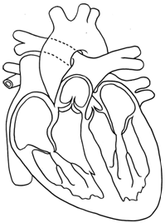

(c) prevent backflow from aorta and pulmonary artery back into the respective ventricles

(d) closing of the atrioventricular valves followed by the semilunar valves

**Question 5**

(a) dose of calcium in diet

(b) weight loss / fat loss

(c) subjects were obese / adults / diet of 500kJ less than normal /length of trial (12 weeks)

(d) amount of exercise / any other supplements in diet / use of drugs

(e) repeat experiment / use more subjects / use wider age groups

**Question 6**

(a) A = distal convoluted tubule, E = Loop of Henle, F = glomerulus

(b) Fluid in D will not contain any glucose or amino acid / less water, Na+, Cl-, HCO3- / more H+, creatinine, K+ / more urea, NH3

(c) Less water loss from body through sweating / evaporation →

the kidney does not need to reabsorb as much water → urine becomes more dilute

**Question 7**

(a) 5,000 decreases to 5 because large plasma proteins cannot pass through the filtration membrane / 5 is reduced to 0 because the amino acids that pass through into the filtrate are fully reabsorbed

(b) decreases through to DCT and then increases slightly in the collecting duct / 440 decreases to 50 because sodium ions are reabsorbed along the tubule / 50 increases to 75 because of water reabsorption in the distal convoluted tubule

(c) Diabetes / Glucose present in urine